Spruce weevil (Pissodes strobi) IWS (alternate name: White pine weevil)
Low priority

Description
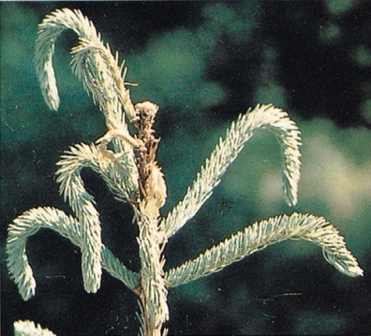
The primary hosts for the white pine weevil are Sitka, white, and Engelmann spruce. Pine and other spruce species are sometimes attacked. Trees 1.5 to 10 m high are preferred. The first sign of attack appears in spring, when small punctures appear near the tip of the previous year's leader, where the adults feed and deposit their eggs. By mid-summer, the current year's leader on attacked trees will be distorted and wilted. This shepherd's crook gradually changes from yellow to red to brown, and is indicative of weevil attack. Signs of previous attacks include deformed or multiple leaders and dead stubs along main stems. This weevil prefers vigorous, open-grown trees, and causes terminal dieback of at least two years' growth. In addition to growing loss, attacks may reduce timber quality by inducing forked and crooked stems. Repeated attacks may allow less desirable species to become dominant over the host species. A severe, lengthy outbreak may reduce stand volume by as much as 30 to 40%.

Extent
Spruce weevil is a low priority forest health factor. The losses resulting from spruce weevil are accounted for in the current operational adjustment factors (OAF 2). Stand level climatic factors and topography are the main factors in weevil development and spread. Although it does not cause mortality, the forking, heavy branching and deformities can cause substantial losses in lumber recovery.

Data
See map at end of this section

Tactics
- The best method of dealing with this insect is to ensure that there is a good species mix on the site. This should be included in the stocking standards for high hazard sites.
- Consider leaving mature deciduous trees on site to act as shade trees. The coolness from the shade may reduce weevil survival.
- Delay spacing until trees are 7 m tall.
- Assess adjacent spruce stands for levels of incidence.
- Incidence levels should continue to be monitored and their priority reassessed at the annual review stage.

Spruce Weevil and Western Spruce budworm Forest Health Stand Establishment Decision Aid
Authors: Don Heppner and Jennifer Turner 2006
http://www.forrex.org/publications/jem/ISS38/vol7_no3_art6.pdf

A Degree Day Hazard Rating System for White Pine Weevil for the Interior of British Columbia
http://www.for.gov.bc.ca/HFD/library/Frbc1997/FRBC1997MR122.pdf

